Thyroid Cancer Detection using FibonacciNet

1. Project Title
Thyroid Cancer Detection using FibonacciNet Deep Learning Model

2. Duration
8 hours

3. Introduction
This project focuses on detecting thyroid cancer using deep learning techniques. It analyzes thyroid ultrasound images and classifies them as benign or malignant. A custom convolutional neural network called FibonacciNet is used to automatically extract features and make predictions. The system aims to assist in early and accurate diagnosis.

4. Aim
To develop a deep learning model that can automatically classify thyroid images as benign or malignant using a CNN-based architecture.

5. Dataset Used
Dataset: Thyroid Classification Dataset (Kaggle)
Format: Image files (.png / .jpg)
Classes: Benign (0), Malignant (1)
Link: https://www.kaggle.com/code/diveshzz/thyroid-classification

6. Tools & Technologies

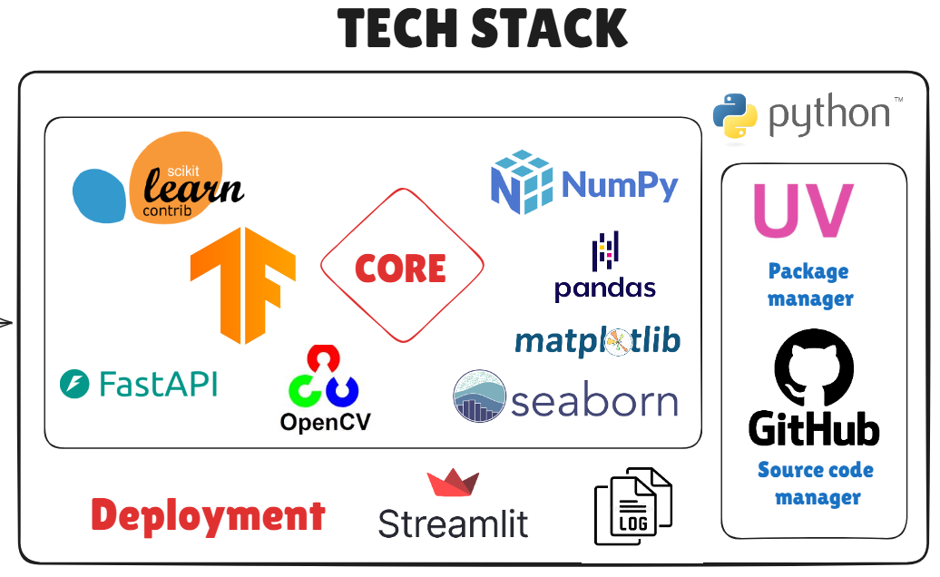

7. Architecture Diagram
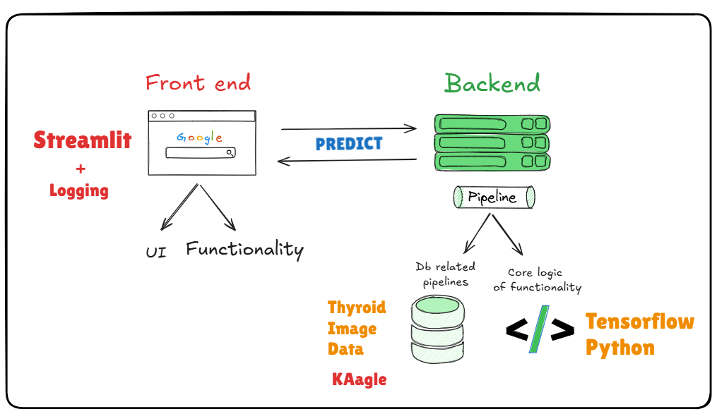

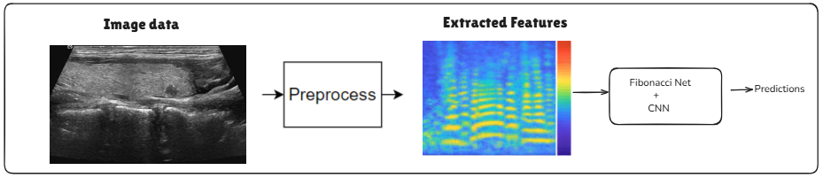

FibonacciNet Model Architecture
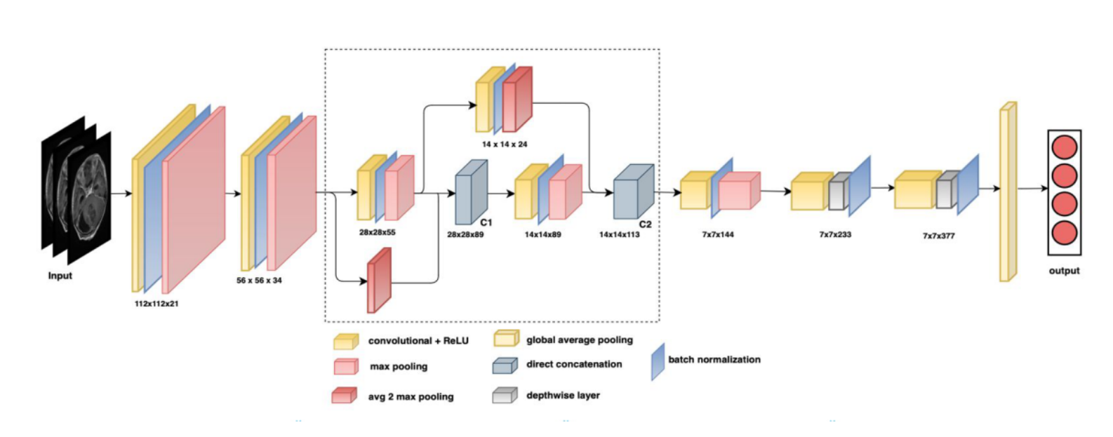

8. Key Steps / Modules
1. Load thyroid image dataset
4. Resize images
5. Normalize pixel values
6. Split dataset
7. Handle class imbalance
8. Train the FibonacciNet model
9. Evaluate model
10. Predict on unseen images
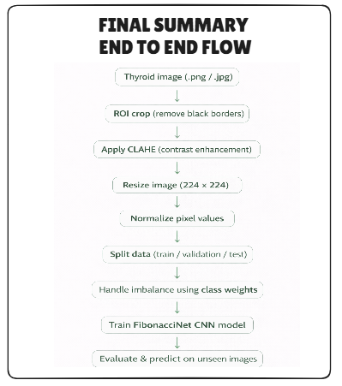

9. Learning Outcomes
- Medical image classification basics
- Image preprocessing techniques
- CNN-based feature extraction
- Custom deep learning models
- Model training and evaluation
- AI in healthcare applications

10. Screenshots

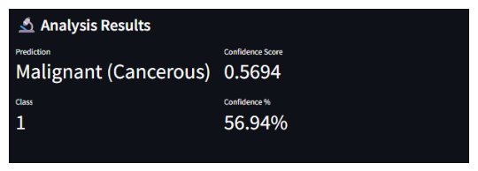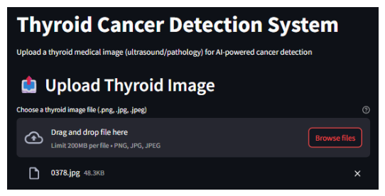

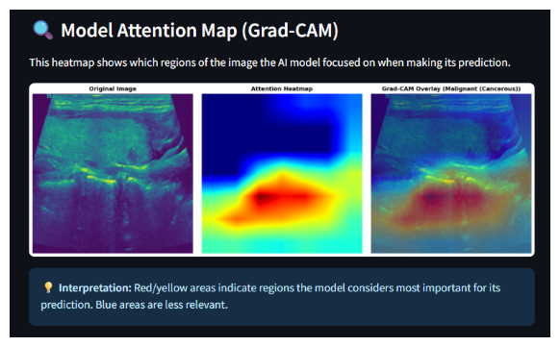

11. Optional Add-ons
- More data for better accuracy
- Web or mobile interface
- Advanced models
- Real-time prediction
- Cloud deployment

12. Resource Links
App Demo: thyroid-cancer-detection.streamlit.app/
--------------------------------------------------------------------------------------------------------------------
PRIMARY LINKS:
Github Project Link: https://github.com/d-hackmt/thyroid_detection_xai
Kaggle Dataset Link: https://www.kaggle.com/datasets/diveshzz/thyroid-cancer-classification-ultrasound-dataset/data
Hugging Face Model Pull: https://huggingface.co/Diveshj/thyroid_models

DOMAIN UNDERSTANDING:
--------------------------------------------------------------------------------------------------------
SECONDARY LINKS:
Python: https://www.python.org/
vs code: https://code.visualstudio.com/
Anigravity: https://antigravity.google/
UV: https://docs.astral.sh/uv/
Git download : https://git-scm.com/
Github login: https://github.com/login
Streamlit Cloud: https://streamlit.io/cloud

